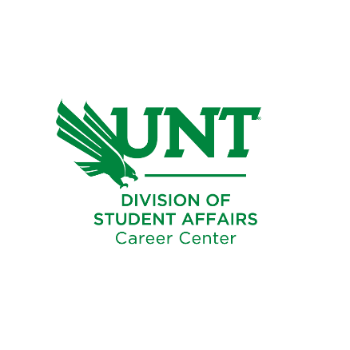

How to Write a Great Cover Letter

Include your contact information in the top right-hand corner. Put your name in bold and larger font to let employers immediately know who you are.

Include the date you are submitting the letter.

Address the letter to the contact person/department/company from the job posting. If possible, call the company and ask for the name of the person responsible for hiring the position you are applying for, or ask for the name of the Human Resources Manager and address the letter to them.

First (Introductory) Paragraph:
Tells the employer: “This is what I want to do! This is why I want to do it with you!”
Introduce yourself, mention the position you are applying for and how you heard about it. Demonstrate you have done your homework on the company/organization; know who they are, what they do, and how good they are to determine what you can do to make them better.
Indicate in a sentence or two what you know about that company. Convey your excitement for the opportunity to be a part of their organization and that you really believe you have the qualifications they are seeking. Then explain that this is why you would like to introduce yourself.

Second (Marketing) Paragraph:
Tells the employer: “This is what I can do for you! This is why I am the best candidate for the position!”
Inform the employer of the degree you have obtained and give details about your background and experience, specifically the experience highlighted on your resume. Match your skills and qualifications with the ones that are required and preferred in the job description. Give specific examples of accomplishments that demonstrate your ability to meet the needs of the employer. This proves that you will be successful in the position you are applying for. Use keywords relevant to the job posting and the industry. Remember to keep all information relevant to the position you are applying for. Refer the reader to the enclosed resume, which will give additional information concerning your background and experience.

Third (Closing) Paragraph:
Tells the employer: “I want an interview! This is what I am willing to do to get it!”
Close by saying you would like to meet with the employer to further discuss your qualifications, the company/organization, or the position. State when you are available for interview and provide the easiest way to contact you to set up a meeting. If you would like to initiate the next step, you can mention that you will follow up in a certain amount of time to determine if the employer has any questions and to set up a personal interview. This is not required, only say you will do this if you actually intend to follow up! If you do call, tell the secretary that the employer is expecting your call. End by saying you look forward to hearing from them.
If you intend to print out your cover letter and hand it to someone, leave room between your closing and your printed name for your signature.
careercenter.unt.edu | Career.Center@unt.edu | 940.565.2105

Your Name
Denton, Texas | (940) 555-1234 | LinkedIn URL | YourEmail@email.com

January 1, 2026

Contact Name, Job Title Department Name Company Name Company Address
City, State Zip Code

Dear Contact:

I recently learned through the University of North Texas Career Center that In Your Face Advertising has openings in the Press and Media Relations Office. In Your Face has a long history as a trendsetter for advertising initiatives in the Dallas/Fort Worth area and is probably best known for its work on the TxDOT “Give ‘Em a Brake” campaigns that have been modeled in the transportation industry around the country. I am seeking a career position in a dynamic advertising environment like that of In Your Face and would like to introduce myself to you.

As you can see from my resume, my background is diverse and appears to meet the profile indicated in your corporate website. I have over four years of experience in customer service, retail sales and promotions, and event planning, and a record of achievement in my communication design degree program. In two years at Cheddar’s restaurant, I was promoted from wait staff to lead waiter then to assistant weekend manager and provided leadership in all aspects of customer service. I have also prepared numerous advertising campaigns as an individual and in small groups, and have compiled a portfolio of my advertising, which is available to you upon request.

I would like to meet with you personally to learn more about In Your Face Advertising and to discuss career opportunities within the company. Please feel free to contact me at 000-000-0000 at your earliest convenience. I am available for an interview immediately and will contact you in one week to ensure you have received the enclosed information. Thank you for your time and consideration. I look forward to meeting with you soon and discussing the exciting work you are doing at In Your Face Advertising.

Sincerely,

Your Name

